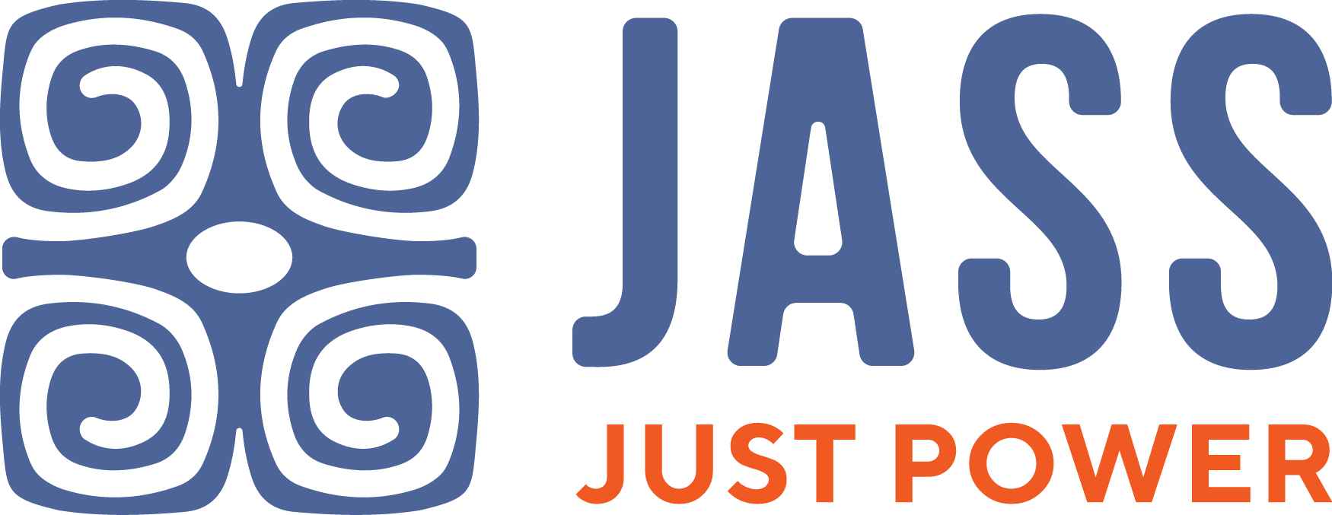

Position: Myanmar/Burma Program Coordinator
Application deadline: May 3, 2022
Report to: Regional Co-Directors
Location: Myanmar/Burma
Salary: Competitive and commensurate with experience;
health benefits

*Open only to Myanmar nationals

JASS Southeast Asia is the regional anchor and network of JASS, an international women’s rights organization dedicated to strengthening the voice, visibility, and collective power of women for justice. We are looking for an energetic community facilitator, with experience in coordinating work with grassroots women’s groups in Myanmar/Burma. This is a great opportunity for a feminist in Myanmar/Burma who is passionate about advancing women’s rights to be a part of a regional feminist team.

Role:
Working closely and under the guidance of the Regional Co-Directors, the Myanmar/Burma Program Coordinator for JASS Southeast Asia will be responsible for the day-to-day coordination of, and communication with partners around priorities and deliverables, ensuring that relationships, programs, and regional initiatives are on track and in line with JASS’ mission and strategy. The ideal candidate brings demonstrated experience in strengthening and coordinating highly collaborative and fast-paced team processes and in navigating shifting priorities in response to opportunities and challenges. We seek an effective Program Coordinator who is extremely organized, accountable, and flexible in taking on whatever task is necessary to ensure the programs’ and team’s success. Experience with grassroots and participatory facilitation, including methodology development is strongly preferred.

Main Responsibilities:
- Coordinates consultative processes for designing, planning and implementing with JASS SEA partners in Myanmar/Burma;
- Coordinates and backstops country-level processes as needed in Myanmar/Burma and including ensuring adequate preparation, logistics, follow up, and after-event reports of the activities and events;
- Supports, communicates, and follows up the plan/process with partners in Myanmar/Burma;
- Designs methodology and facilitates the workshop as needed both in Myanmar/Burma and at the regional level;
- Produces brief monthly updates on relevant contextual issues and identifies key opportunities both at the country and regional levels to contribute to decision-making and strategic planning processes as appropriate;
- Provides support on Monitoring, Evaluation, and Learning (MEL), Communications and Knowledge Development at the regional and global levels;
- Performs related activities to support JASS program and organizational development at country, regional, and global levels; and
- Supports the Regional Co-Director/s in delivering JASS’s expected program goals and objectives.

Skills and qualities:
- Has the ability in organizing and facilitating training/capacity building activities with diverse groups at grassroots level;
- Has a good networking and communication skills and experience in using social media platforms;
- Has the ability to think critically and politically, anticipate needs and problem-solve;
- With experience in setting up clear processes and coordinating around tight deadlines and multiple priorities; and in promoting teamwork in a multigenerational, multicultural context where everyone contributes;
- Is passionate about advancing women’s rights and keen on self-development;
- An open-minded, high responsible person with ability to work independently and virtually;
- With strong interpersonal skills and a genuine relationship-builder; working with a range of people from grassroots activists – JASS’ core constituency – to donors, policy advocates, social justice and/or women’s rights organizations in Myanmar/Burma and region;
- With experience in working effectively with limited budgets and a corresponding ability to draft and implement budgets for country projects and initiatives;
- Is able to travel within the country and abroad; and
- has a sense of humor!

How to Apply: Please submit a cover letter, curriculum vitae, and relevant writing sample via email to southeastasia@justassociates.org. JASS is an equal opportunity employer. Applicants with diverse backgrounds and members of the queer/transgender community are strongly encouraged to apply.

Only shortlisted applicants will be contacted.

